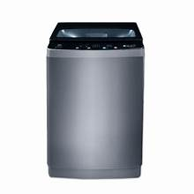

***Pel 9160LF automatic loaded washing machine loaded***

* **Color:**Black/White
* **Available:**Out of Stock
* **Motor type:**Induction
* **Program:**10
* **Old Price:**~~Rs 40,000~~
* **New Price:**Rs 34,400